# **Macan**

Porsche Macan air suspension systems will provide an excellent and comfortable ride experience for the first 3-5 years after the vehicle leaves the factory. Slowly over time many of the rubber components will start deteriorating. This slow degradation of the rubber components such as Air Springs or Air Struts Rubber Bladders will cause small, sometimes barely visible cracks or pinholes that will cause air in the system to slowly escape. When there is an air leak in your Porsche Macan air suspension system, it can cause the air suspension compressor or other electrical components to overwork and burn out. When Porsche Macan air struts or air spring bags go out, your Porsche Macan is nearly impossible to drive. BAVARIA CENTER provides many solutions for your air suspension repair. We offer many Aftermarket Parts, New or Remanufactured, including Air Struts, Air Spring Bags, Compressors, Air Supply Solenoid Valve Blocks and more.

# **Porsche Macan (95B) Air suspension strut front**

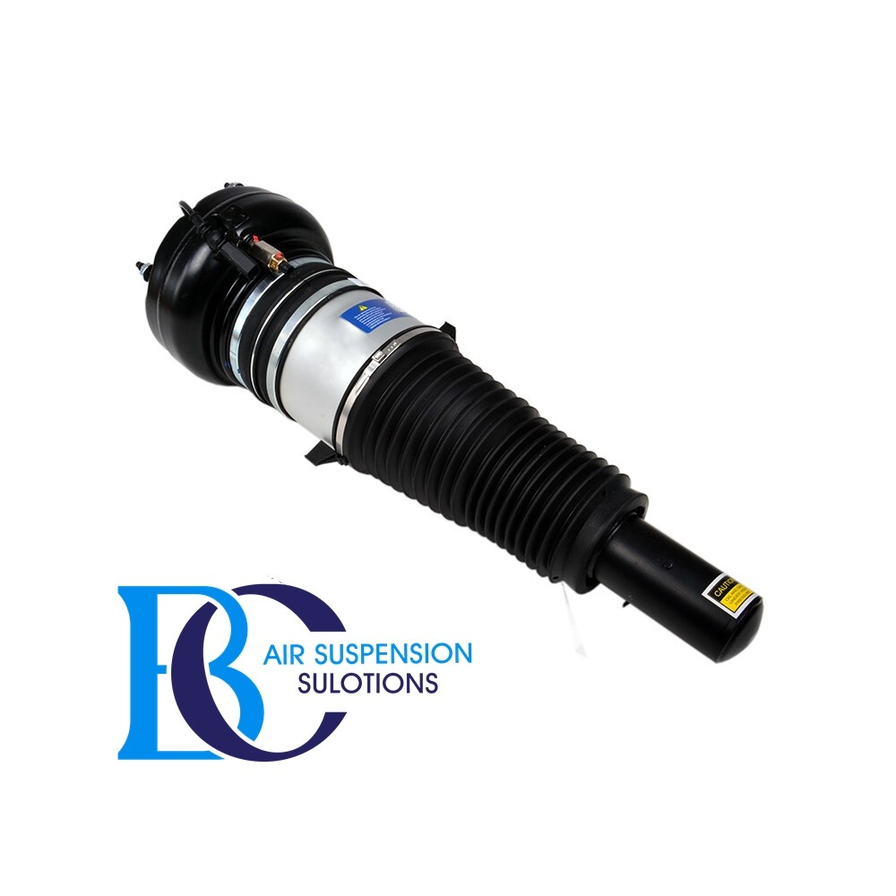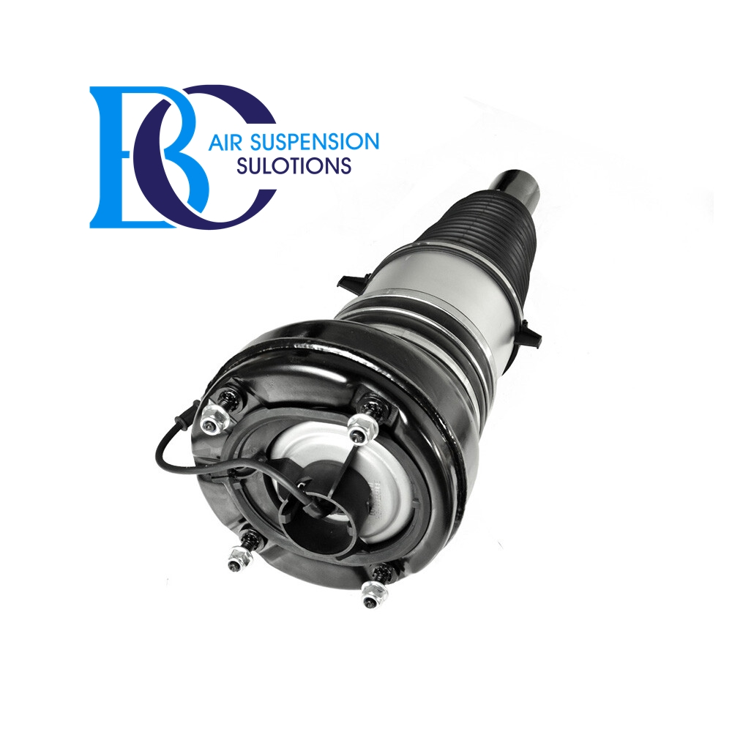

**Description**

This is a new shock absorber for the front air suspension of Porsche Macan (95B).

**Can be installed in the following vehicles:**

Porsche Macan 95B (2014--)

**OEM part number:**

95B616039AE, 95B616039, 95B616039T, 95B616039S, 95B616039R, 95B616039P, 95B616039M, 95B616039K, 95B616039J, 95B616039H.

# **Porsche Macan (95B) Air Spring air suspension Rear**

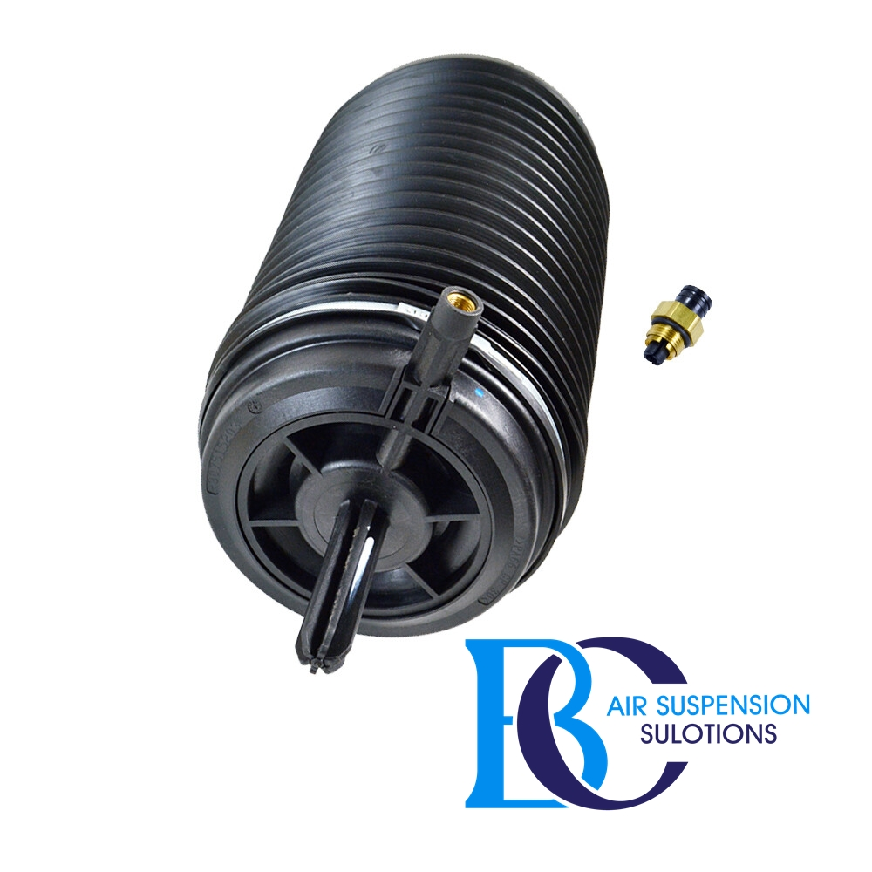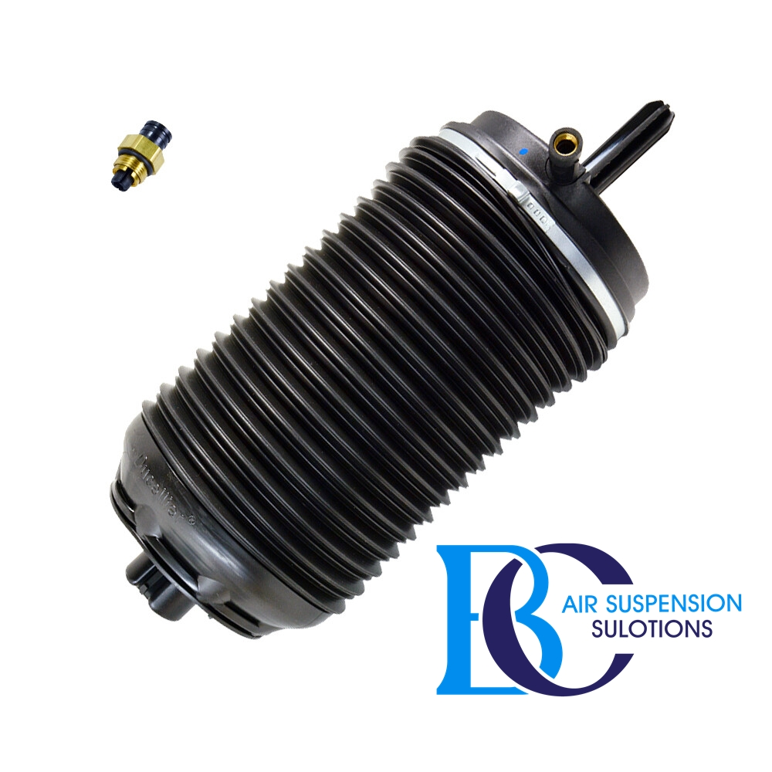

**Description**

This is the rear air spring for the Porsche Macan (95B).

**It can be installed in the following vehicles:**

Porsche Macan 95B (2014-2018)

**OEM part numbers:**

95B616001H, 95B616001F, 95B616002H, 95B616002F.

# **Porsche Macan (95B) Compressor air suspension**

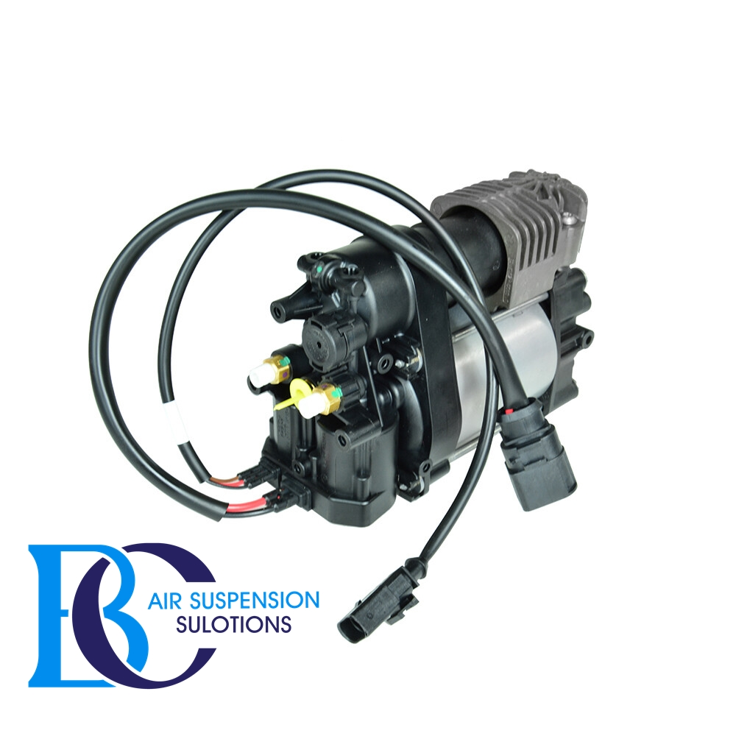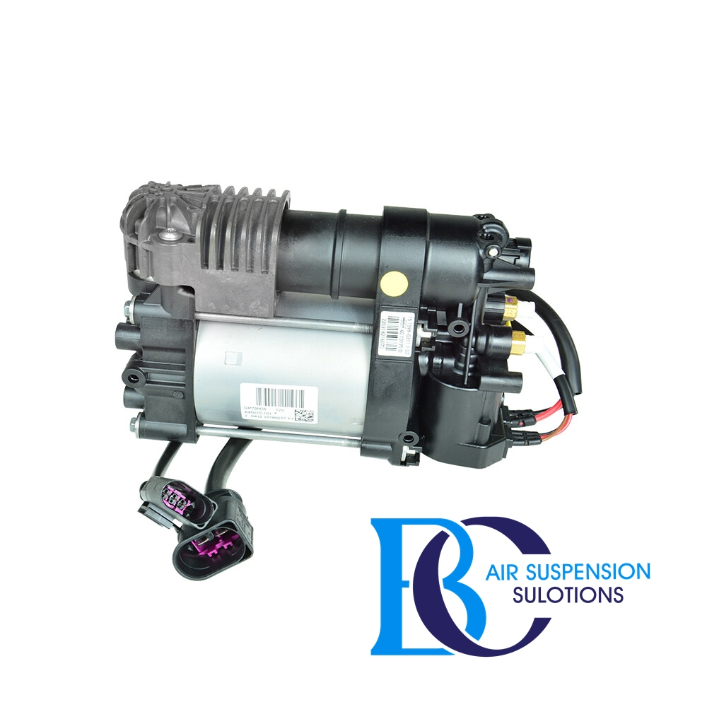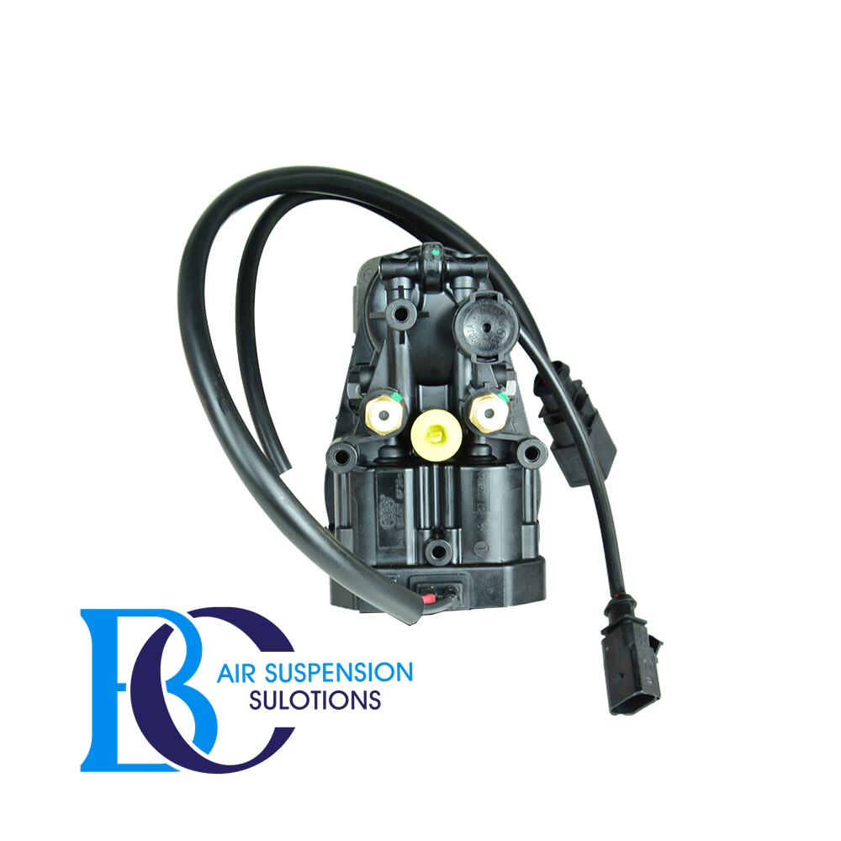

**Description**

This is the compressor for the air suspension of the Porsche Macan (95B).

**Can be installed in the following vehicles:**

Porsche Macan (95B) 2014--

**OEM part number:**

95B616006, 95B616006F, 95B616006E, 95B616006D

# **Porsche Macan Valve unit air suspension**

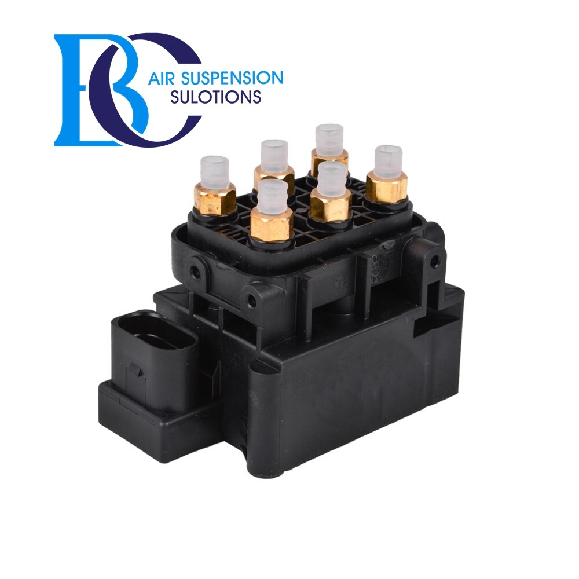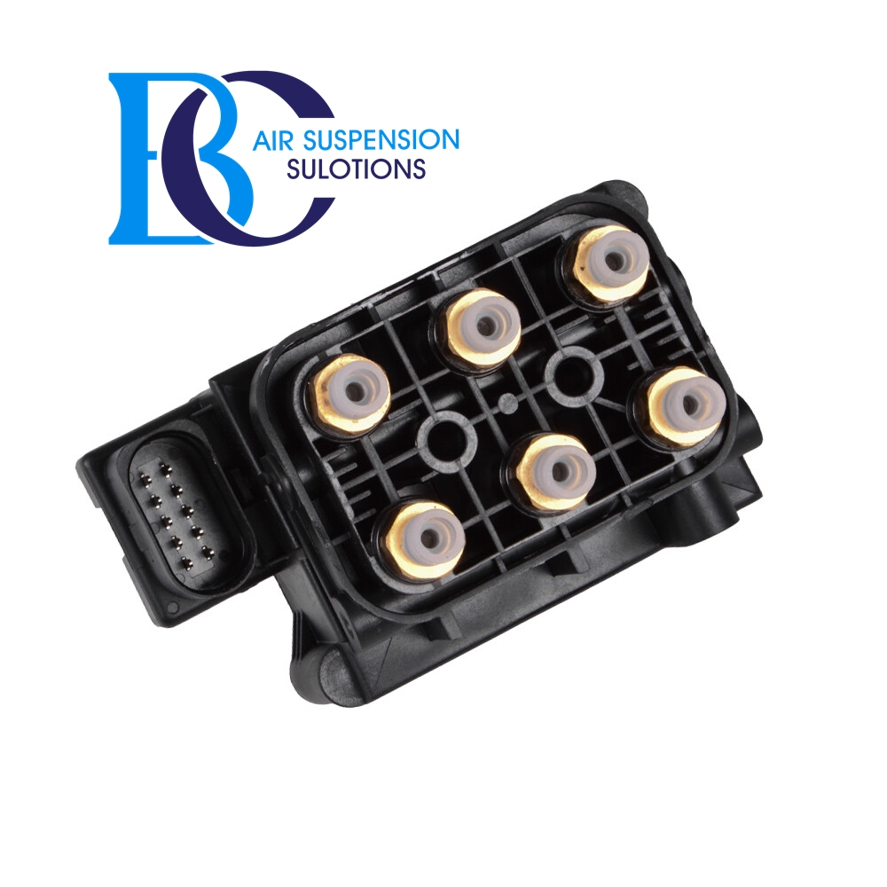

**Description**

This is the control valve for the air suspension of the Porsche Macan.

**Can be installed in the following vehicles:**

Porsche Macan (95B) 2014--

**Valve replaced with the spare part numbers:**

7P0616014